Traffic signal Led
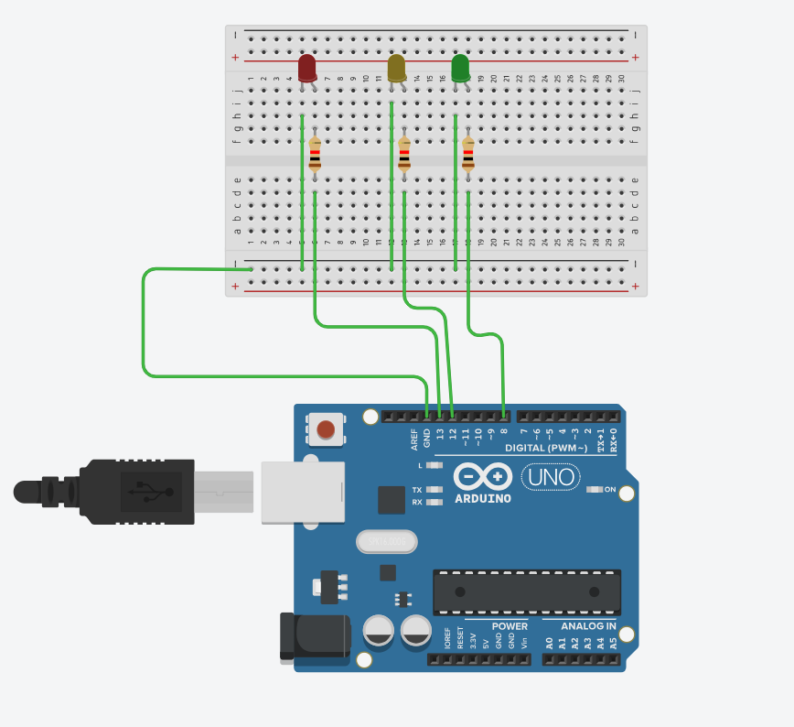
int led1 = 13;
int led2 = 12;
int led3 = 8;

void setup()
{
pinMode(led1, OUTPUT);
pinMode(led2, OUTPUT);
pinMode(led3, OUTPUT);

}

void loop()
{
digitalWrite(led1, HIGH);
delay(100); // Wait for 1000 millisecond(s)
digitalWrite(led1, LOW);
delay(100); // Wait for 1000 millisecond(s)

digitalWrite(led2, HIGH);
delay(100); // Wait for 1000 millisecond(s)
digitalWrite(led2, LOW);
delay(100); // Wait for 1000 millisecond(s)

digitalWrite(led3, HIGH);
delay(100); // Wait for 1000 millisecond(s)
digitalWrite(led3, LOW);
delay(100); // Wait for 1000 millisecond(s)

digitalWrite(led2, HIGH);
delay(100); // Wait for 1000 millisecond(s)
digitalWrite(led2, LOW);
delay(100); // Wait for 1000 millisecond(s)

digitalWrite(led1, HIGH);
delay(100); // Wait for 1000 millisecond(s)
digitalWrite(led1, LOW);
delay(100); // Wait for 1000 millisecond(s)
}

